Session 9 - 1
import java.util.*;
class Solution {
public List<List<String>> groupAnagrams(String[] strs) {
Map<String, List<String>> map = new HashMap<>();

for (String s : strs) {
char[] charArray = s.toCharArray();
Arrays.sort(charArray);

String key = new String(charArray);

if (!map.containsKey(key)) {
map.put(key, new ArrayList<>());
}

map.get(key).add(s);
}

return new ArrayList<>(map.values());
}
}
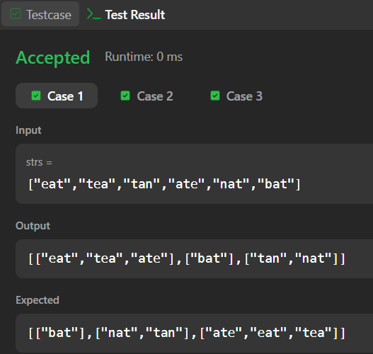

Session 9 - 2

import java.util.*;
class Solution {
public int[] topKFrequent(int[] nums, int k) {
Map<Integer, Integer> frequencyMap = new HashMap<>();
for (int num : nums) {
frequencyMap.put(num, frequencyMap.getOrDefault(num, 0) + 1);
}
List<Integer>[] buckets = new List[nums.length + 1];
for (int key : frequencyMap.keySet()) {
int frequency = frequencyMap.get(key);
if (buckets[frequency] == null) {
buckets[frequency] = new ArrayList<>();
}
buckets[frequency].add(key);
}
int[] result = new int[k];
int index = 0;

for (int i = buckets.length - 1; i >= 0 && index < k; i--) {
if (buckets[i] != null) {
for (int num : buckets[i]) {
result[index++] = num;
if (index == k) {
return result;
}
}
}
}
return result;
}
}

